DIAGNOSTIC CODES: D0100 - D0999

EXAMS: Most of these exams will fall under the preventive coins category which is most often 100%. I always ask about the problem focused exam as many times, it falls under the basic services on a plan and the deductible will apply. Often all of these exams combined together will share the frequency limit.

D0150: COMPREHENSIVE EXAM - NEW OR ESTABLISHED PATIENT (IE)
- A comprehensive evaluation for a NEW patient or patient of record who has been absent from dental treatment for 3 or more years.
- A thorough evaluation - hard and soft tissue, x-rays if needed, oral cancer screening, medical history, dental history and a general health assessment.
D0140: LIMITED ORAL EVALUATION - PROBLEM FOCUSED (LE)
- An exam limited to a health problem or a chief complaint
- This exam is done when a patient presents with a specific problem, dental emergency, trauma or acute infection
D0120: PERIODIC ORAL EVALUATION - ESTABLISHED PATIENT (PE)
- An exam done on a patient of record to determine any changes in dental health or medical health
D0145: ORAL EVALUATION FOR A PATIENT UNDER 3 YEARS OF AGE
- Diagnostic exam for a child under the age of 3 years.
- Includes oral and physical health history, evaluation of caries rate, development of oral care instructions with the child’s parent or caregiver
D0180: COMPREHENSIVE PERIODONTAL EVALUATION - NEW OR ESTABLISHED PATIENT
- This exam is for patients showing signs or symptoms of periodontal disease
- Includes evaluation of periodontal conditions, probing, charting, patient’s dental and medical history and general health assessment. recording of dental caries, missing teeth, occlusal relationships, restorations, and oral cancer evaluation
D0170: Re-evaluation - NOT a POST OP APPOINTMENT
- An exam assessing the status of a previously existing condition (a traumatic injury to monitor, evaluation for undiagnosed pain, etc. )
D0171: Re-evaluation - POST OP VISIT
- An exam to evaluate healing after a procedure

DIAGNOSTIC IMAGING (XRAYS)

Bitewing X-rays: These x-rays are used to check for any decay or cavities in between the teeth. These x-rays will show only the crowns of the teeth

D0274: Adult Bitewing X-rays 4 films – 2 on each side (BWX)
- Recommended at least once a year or 1 every 12 months
- Insurance: Most common coverage is under diagnostic services at 100% coinsurance
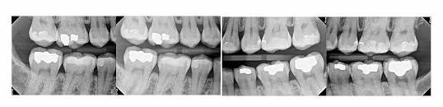
D0272: Child Bitewing X-rays – 1 on each side (BWX)
- Recommended at least once every year or 1 every 12 months
- If a child has a high caries rate - it may be recommended to have 1 every 6 months

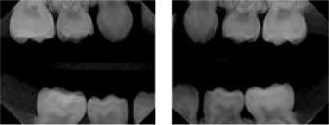
D0220 & D0230: Periapical X-rays: (PA)
- These x-rays are taken when a patient has a toothache or when a crown is recommended
- If we are monitoring a tooth for a patient, we may take a film at their recall appointment
- Both the crown and the root are shown in these films
- Billing: For the first film, use the code D0220
- Billing: For each additional film, use the code D0230
- Example: 4 PA’s were taken use the following codes: D0220, D0230, D0230, D0230
- Frequency varies with each insurance plan
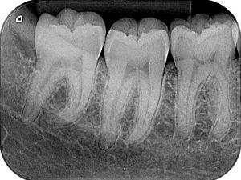
- Insurance Coverage: The most common is diagnostic at 100%. Becoming more common - these films fall under the Basic category and the deductible would apply

D0240: Occlusal Films: (OCC)
- These images are taken on children and are used to help track the development and placement of a section or entire arch of teeth in the upper or lower jaw.
- Insurance Coverage: Most commonly under diagnostic services at 100%, but can be covered under the Basic category and the deductible would apply
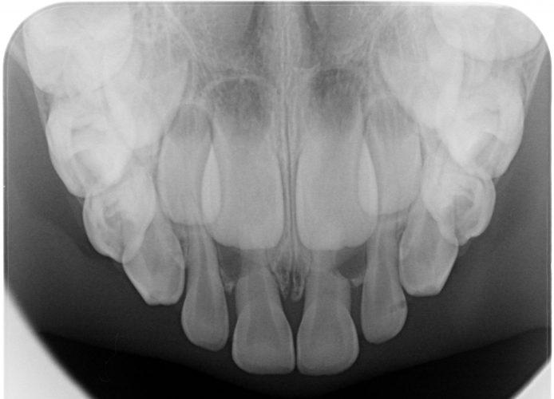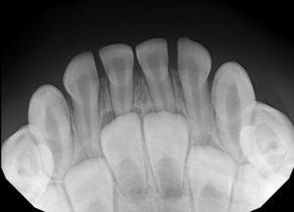

D0210: Full Mouth Series – Comprehensive xrays typically done on new patients and done every 3 – 5 years. (FMX)
- Checking for decay and infection. Typically taken every three to five years, an FMX captures detailed images of each tooth and the surrounding structures. Using a combination of Bitewing and Periapical x-rays, they are used to diagnose dental conditions such as gum disease, cavities, dental abscesses and lesions
- Insurance Coverage: Most commonly under diagnostic services at 100% and have a frequency limit of
3 - 5 years. Note - the frequency limit may be in # months format (Example: 1/36 months)
- This will most often share frequency with panorex x-ray (D0330)
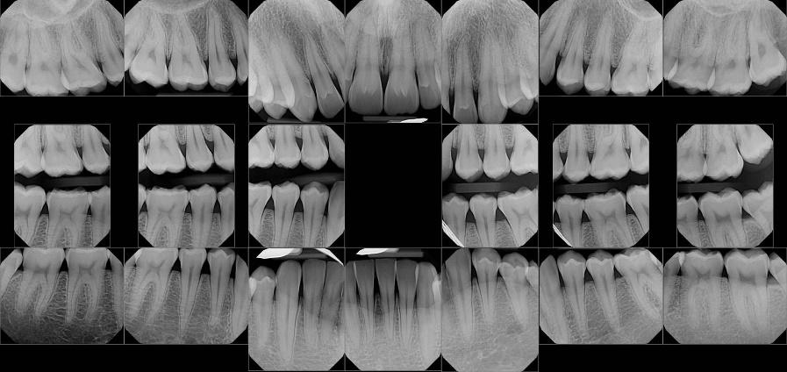

D0330: Panorex xrays (PANO)
- Typically done on children beginning at around ages 6 - 9
- Also done for teens around the ages of 16 - 18 to check for wisdom teeth
- Can also see cysts, abscesses, missing teeth
- Insurance Coverage: Most commonly under diagnostic services at 100% and a frequency of 3 - 5 years
- This will most often share frequency with Full Mouth Series (D0210)
- Beginning to see more insurance plans cover this under Basic services and the deductible would apply
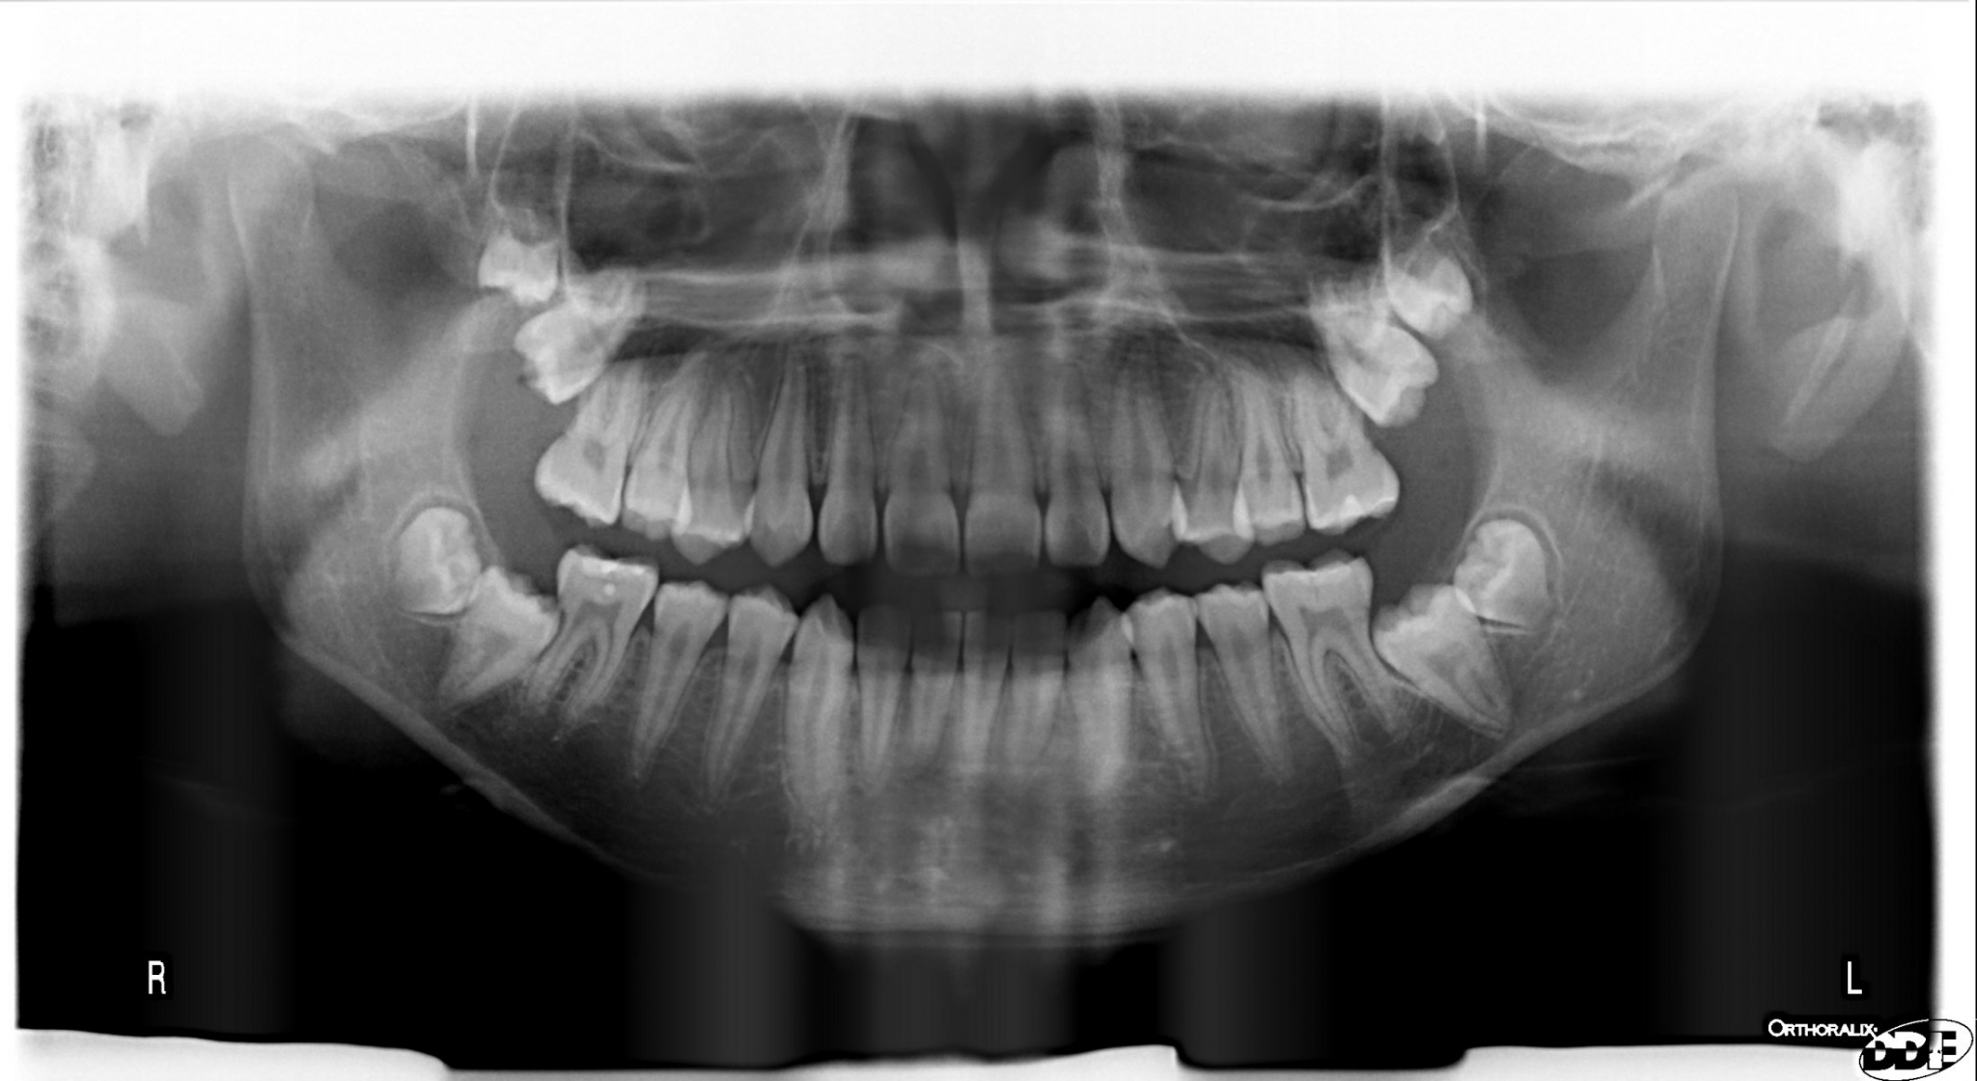

D0367: CBCT Image
- A CBCT scan shows all your bones, nerves, and soft tissues in high detail allowing providers to diagnose the treatment approach prior to beginning.
- Notably, this technology is a key step in planning and performing successful dental implant surgery. And also used for extraction of Wisdom Teeth.
- Insurance Coverage: Typically will not cover this image. Our office offers this as a complimentary service.
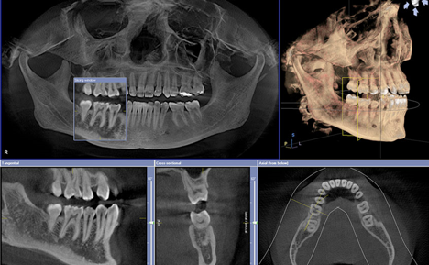
PREVENTIVE CODES: D1000 - D1999
DENTAL PROPHYLAXIS (CLEANINGS)
D1110: PROPHYLAXIS - ADULT (PXa)
- Removal of plaque, calculus and stains from teeth, implants
- Intended to control local irrational factors
- Insurance Coverage: Most commonly covered under Preventive services at 100%

D1120: PROPHYLAXIS - CHILD (PXc)
- Removal of plaque, calculus and stains from teeth in the primary and transitional dentition
- Ages vary based on the insurance plan, but most common use this code through the age of 13

FLUORIDE TREATMENT
D1206: TOPICAL APPLICATION OF FLUORIDE VARNISH
- Insurance coverage most often under preventive at 100%
- Most often there is an age limit and a frequency limit
- VAIL RESORTS (GUARDIAN) WILL NOT COVER THIS CODE
D1208: TOPICAL APPLICATION OF FLUORIDE - EXCLUDING VARNISH
- Insurance coverage is most often under preventive at 100%
- Most often there is an age limit and a frequency limit

DENTAL SEALANTS: A dental sealant is a thin, plastic coating painted on the chewing surfaces of the teeth to prevent tooth decay on the chewing surface. The sealant bonds into the depressions and grooves of the teeth, forming a protective shield over the enamel of each tooth.
D1351: SEALANT - PER TOOTH
- Insurance Coverage: This can be covered under Preventive services or Basic services
- Covered on virgin (untouched) permanent molars (1st and 2nd molars) on the chewing surface
- There is a frequency limit and an age limit
- Bicuspid teeth, baby teeth or any surface other than the occlusal surface are generally not covered
D1352: PREVENTIVE RESIN RESTORATION
- This is a conservative restoration of active decay that does not extend into the dentin
- ALWAYS estimate no insurance coverage for this code
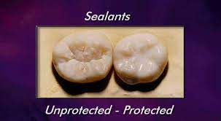

SPACE MAINTAINERS: An appliance designed to prevent tooth movement. Usually to save the space for a baby tooth that has been lost prematurely
- Insurance Coverage: Can be under Preventive services or Basic services
- Typically an age limitation and a frequency limit

D1510: Fixed, unilateral (one side)
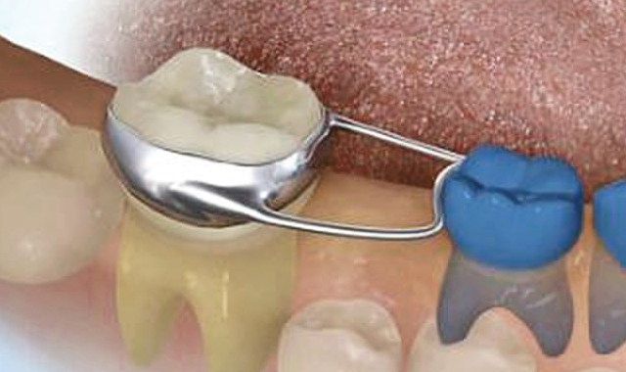

D1516/D1517: Fixed, bilateral (D1516 - maxillary) (D1517 - mandibular)
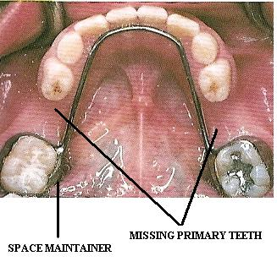

RESTORATIVE CODES: D2000 - D2999
These codes most often fall under the Basic category with insurance
*** An exception to this, would be the code D2950 - build up. This can be covered under Major services

Fillings:
Anterior or Front teeth: Maxillary teeth (#’s 6, 7, 8, 9, 10, 11)
Mandibular teeth (#’s 22, 23,24,25,26,27)

D2330: 1 Surface - Placed on one of the following (Mesial, Distal, Incisal, Lingual or Facial)
D2331: 2 Surface - Placed (without interruption) on two of the surface classifications (Mesial, Distal,
Incisal, Lingual or Facial)
D2332: 3 Surface - Placed (without interruption) on three of the surfaces (Mesial, Distal, Incisal,
Lingual or Facial)
D2335: 4 or more Surfaces - Placed (without interruption) on 4 or more of the surfaces (Mesial,
Distal, Incisal, Lingual or Facial)

Posterior or Back teeth: Maxillary teeth (#’s 1,2,3,4,5, 12,13,14,15,16)
Mandibular teeth (#’s 17, 18,19,20,21, 28,29,30,31,32)

D2391: 1 Surface - Placed on one of the following (Mesial, Distal, Occlusal, Lingual or Buccal)
D2392: 2 Surface - Placed (without interruption) on two of the surface classifications (Mesial, Distal,
Occlusal, Lingual or Buccal)
D2393: 3 Surface - Placed (without interruption) on three of the surfaces (Mesial, Distal, Occlusal,
Lingual or Buccal)
D2394: 4 or more Surfaces - Placed (without interruption) on 4 or more of the surfaces (Mesial,
Distal, Occlusal, Lingual or Buccal)

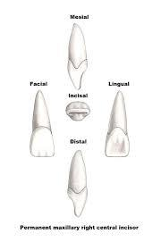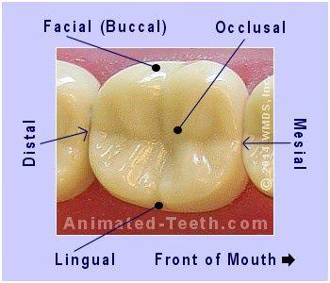

1 Surface Anterior Examples

D2330 - 1 Surface on Facial (F) D2330 - 1 Surface on Lingual (L)

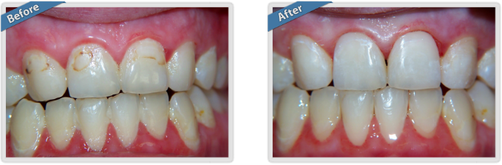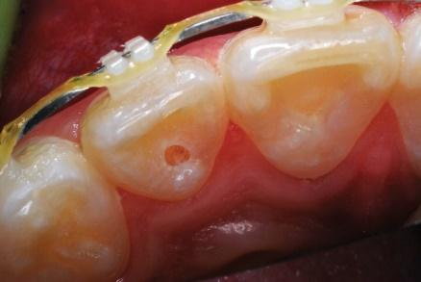

2 Surface Anterior Examples

D2331 - 2 Surface on Mesial Lingual (ML) D2331 - 2 Surface on Distal Lingual (DL)

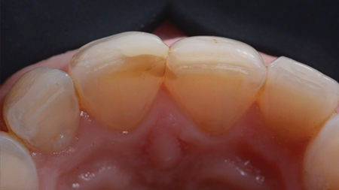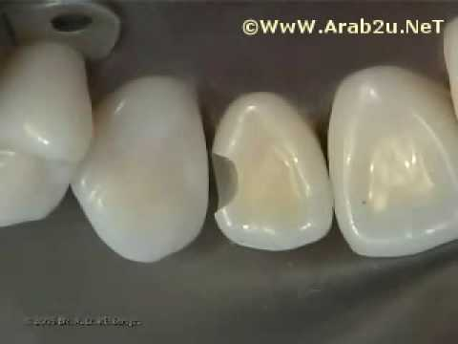

D2331 - 2 Surface on Mesial Facial (MF) D2331 - 2 Surface on Distal Facial (DF)
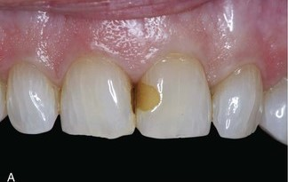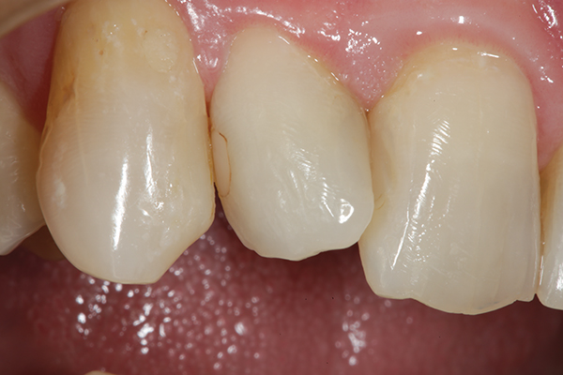

D2331 - 2 Surface on Incisal Lingual (IL) D2331 - 2 Surface on Incisal Facial (IF)

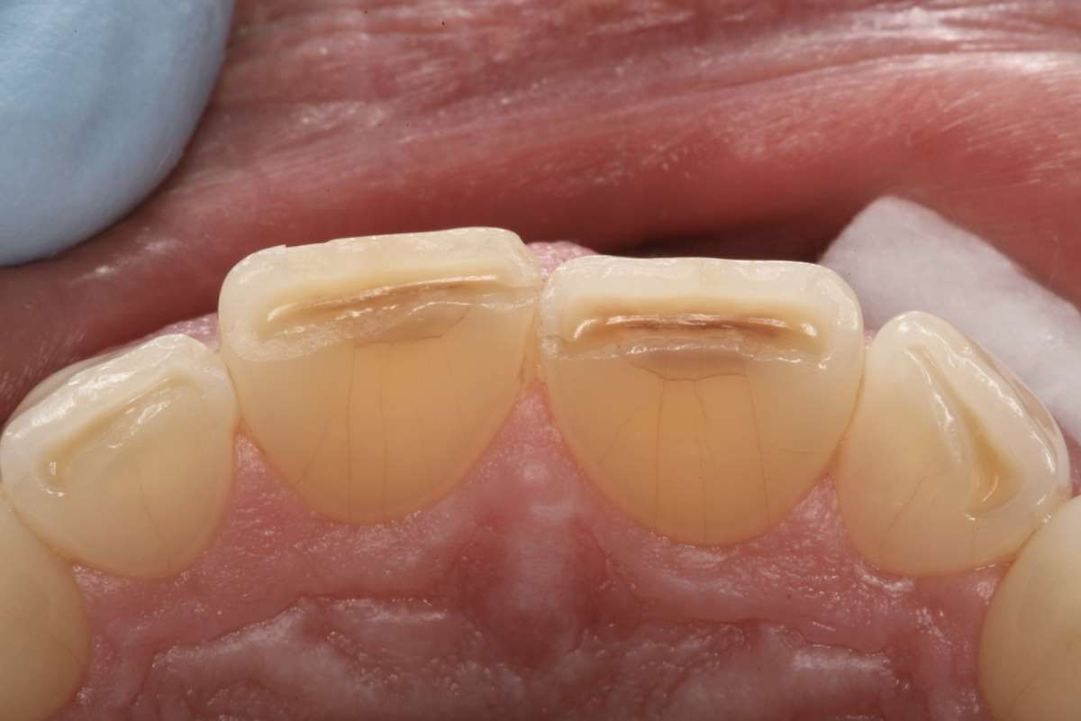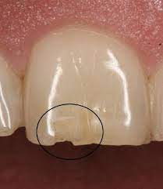

3 Surface Anterior Examples

D2332 - 3 Surface on Mesial Incisal Facial (MIF) D2332 - 3 Surface on Distal Incisal Facial (DIF)

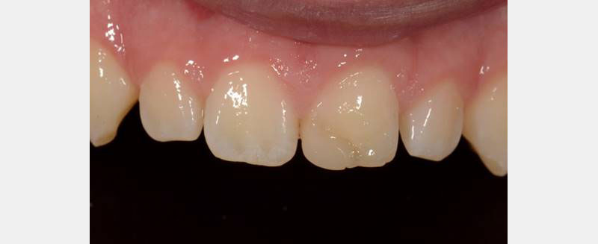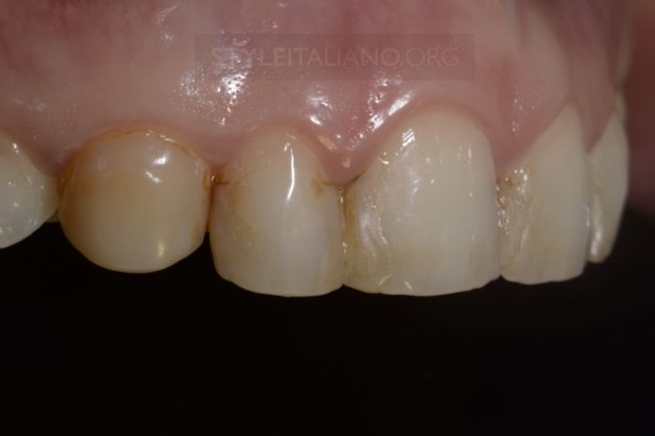

D2332 - 3 Surface on Mesial Facial Lingual (MFL) D2332 - 3 Surface on Distal Facial Lingual (DFL)

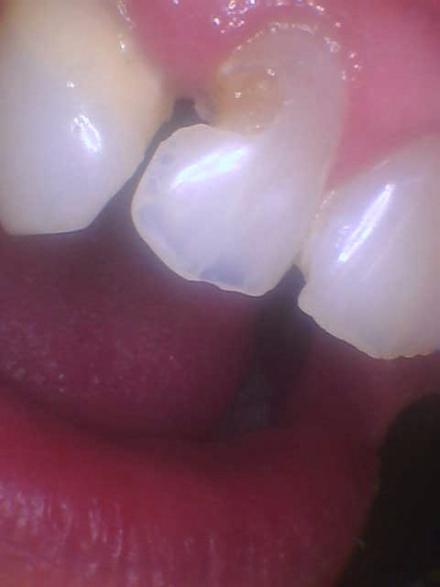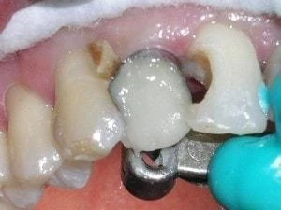

4 or more surface Anterior Examples

D2335 - Mesial Facial Incisal Lingual (MFIL) D2335 - Mesial Facial Distal Incisal Lingual (MFDIL)

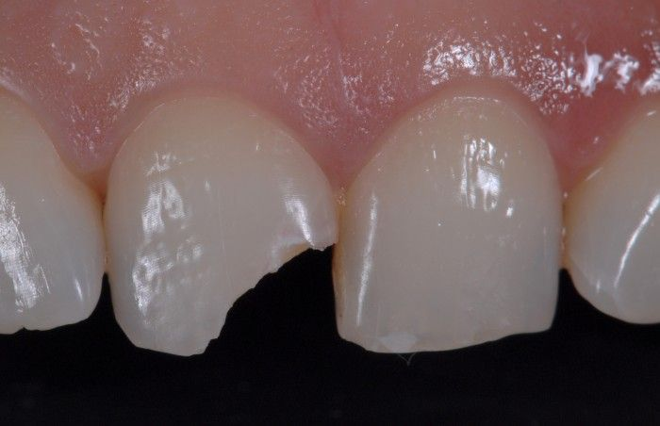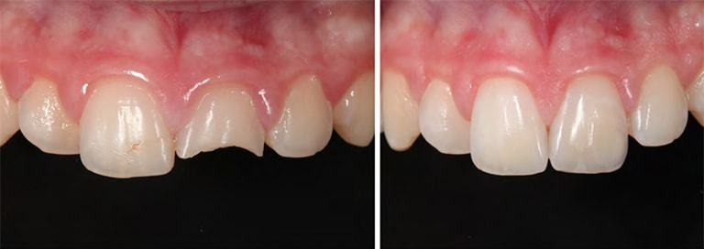

D2335 - Distal Facial Incisal Lingual (DFIL)

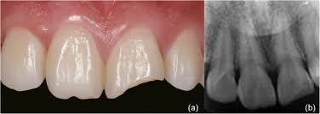

Posterior Examples

Composite fillings are very commonly downgraded to an amalgam filling code - It can be on all posterior teeth (bicuspids and molars) or only on molars

What is the difference?

- The color is the most noticeable difference
- The cost: Composite fillings are more expensive and most insurance companies will not pay for the more expensive material, but will downgrade to a less expensive material
- Silver fillings expand and contract with temperature changes thus causing stress on the tooth the filling is in, sometimes causing it to crack or to allow bacteria to get underneath the amalgam filling
- Composite fillings do not change in shape or siz

1 Surface Posterior Examples

D2391 - Occlusal Surface (O) —--------> Downgraded Code D2140 - 1 Surface Amalgam

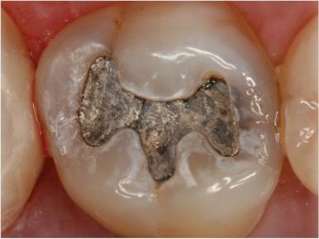
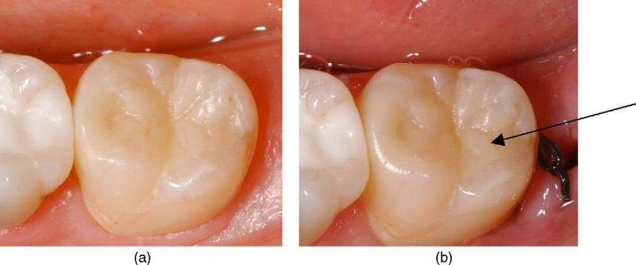

D2391 - Buccal Surface (B) D2391 - Lingual Surface (L)
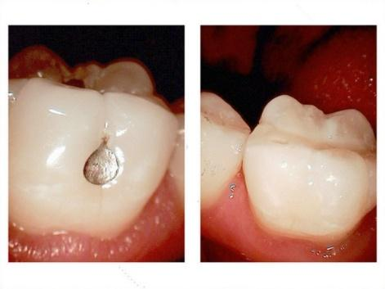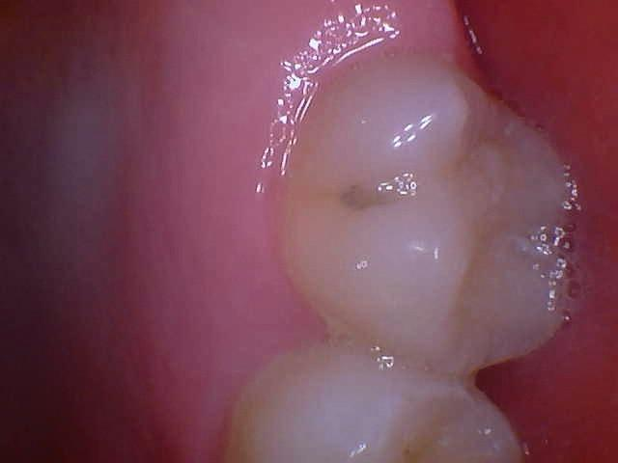

2 Surface Posterior Examples

D2392 - 2 Surface Posterior Resin —--------> Downgraded Code D2150 - 2 Surface Amalgam

D2392 - Mesial Occlusal (MO) D2392 - Distal Occlusal (DO)
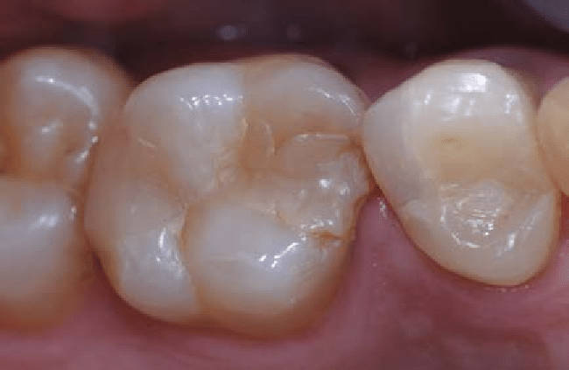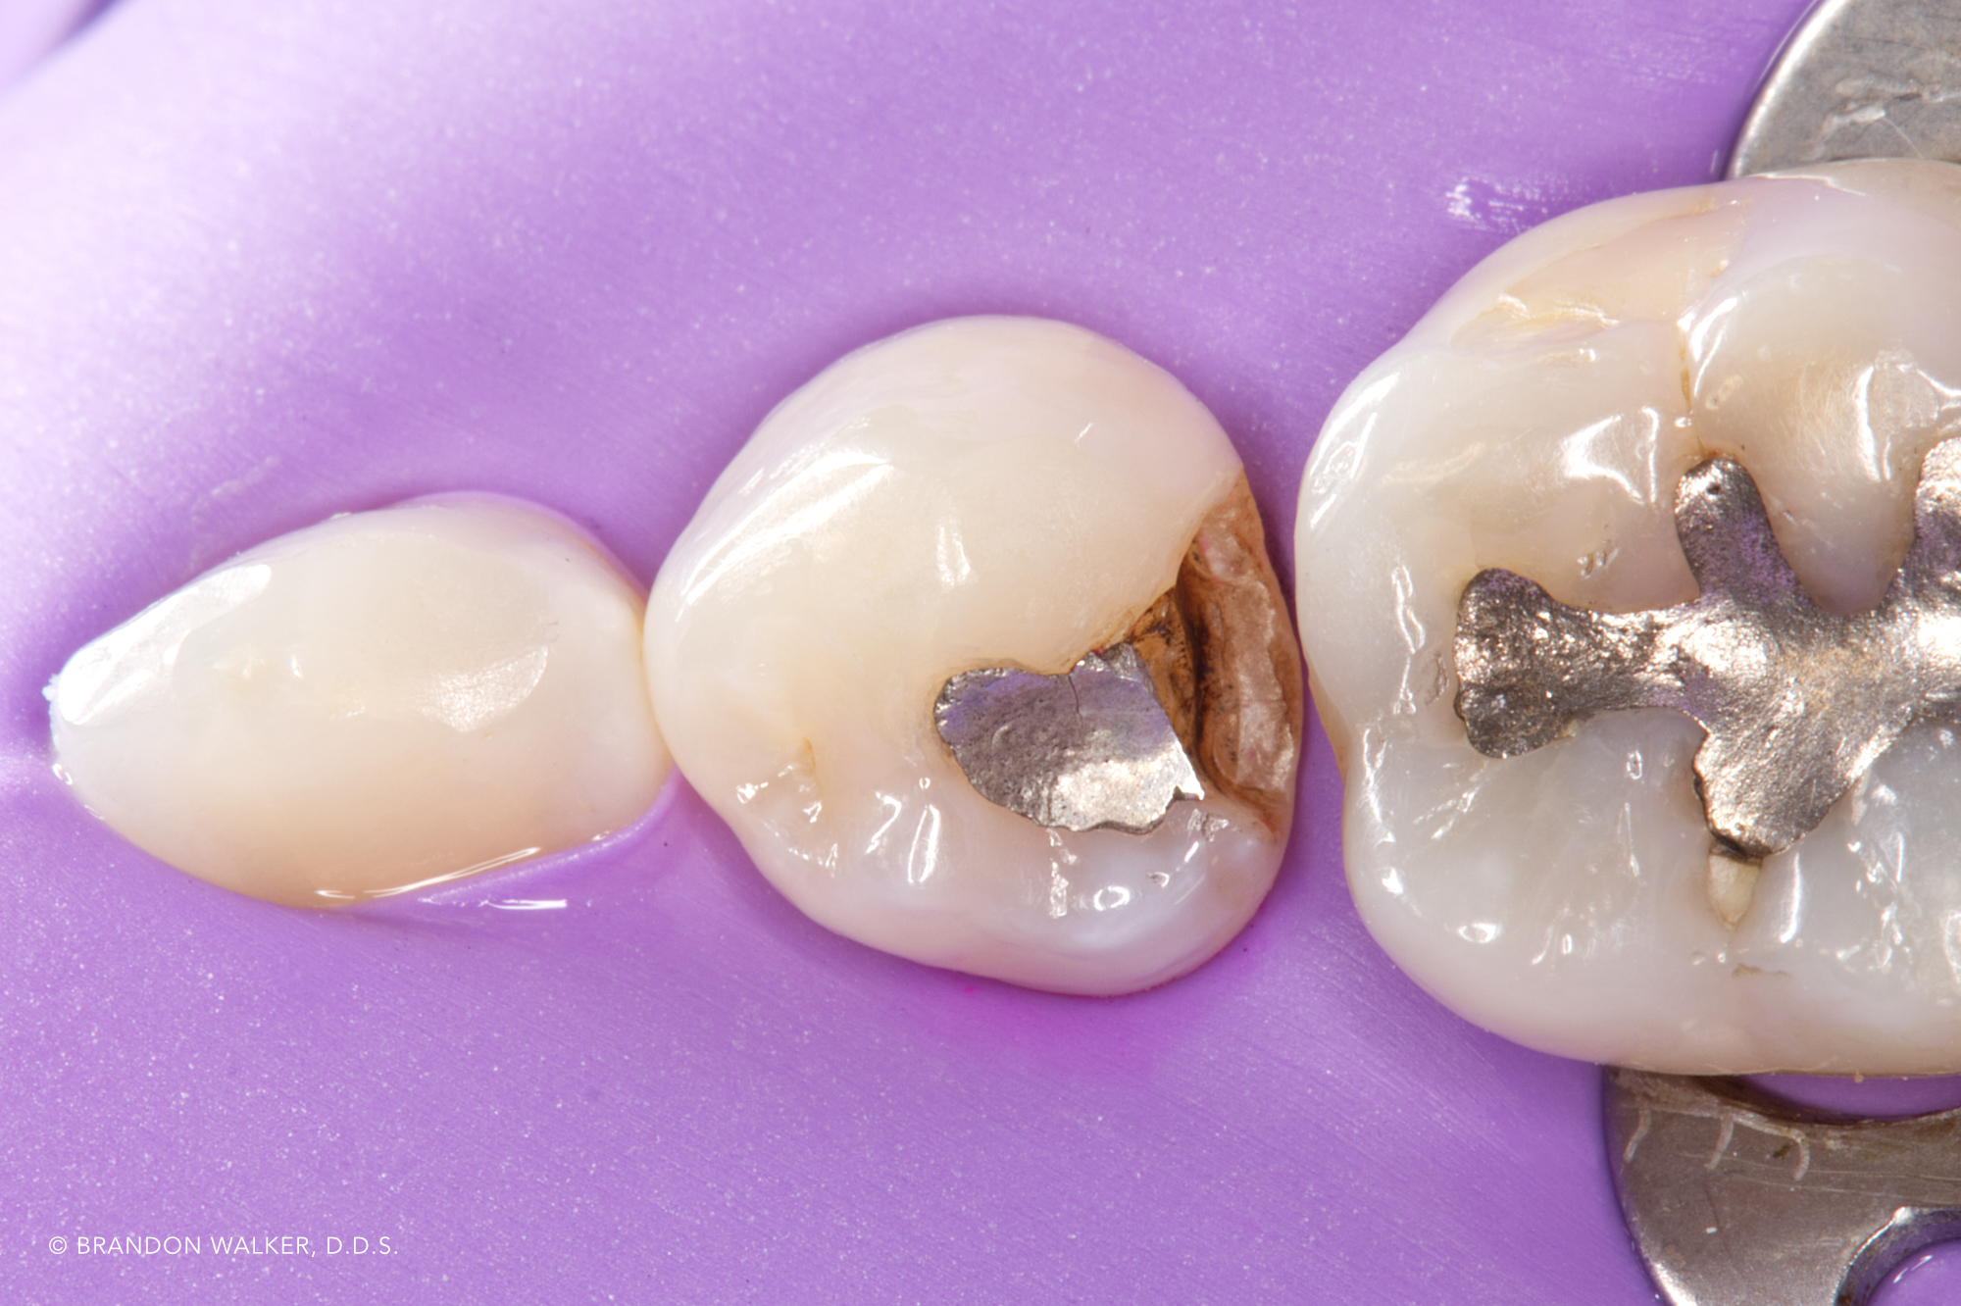
*An amalgam filling to show the surfaces

D2392 - Occlusal Lingual (OL) D2392 - Occlusal Buccal (OB)
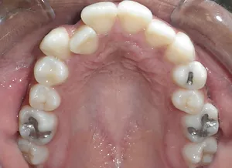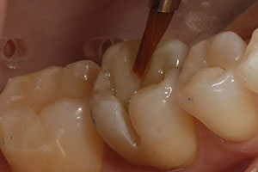
*Amalgam filling to show surfaces

3 Surface Posterior Examples

D2393 - 3 Surface Posterior Resin —--------> Downgraded Code D2160 - 3 Surface Amalgam
D2393 - Mesial Occlusal Distal (MOD) D2393 - Mesial Occlusal Lingual (MOL)

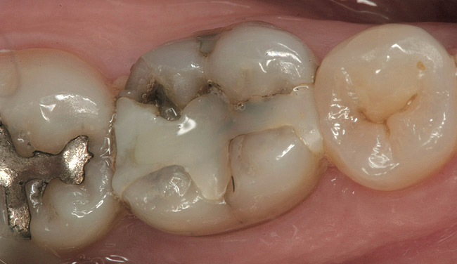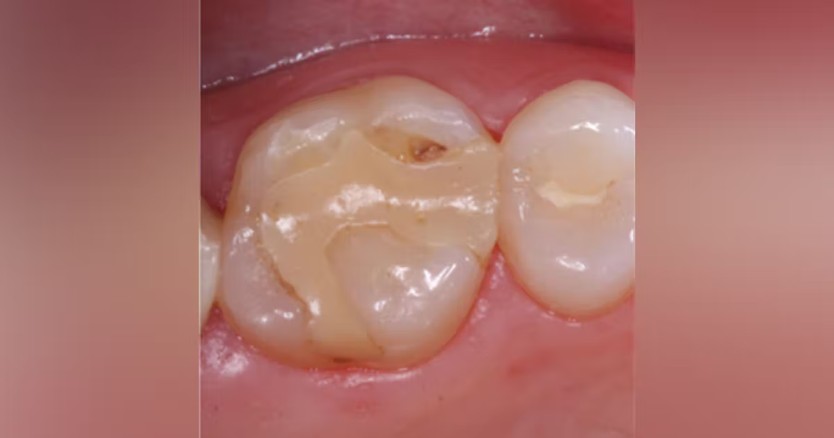

D2393 - Distal Occlusal Buccal (DOB) D2393 - Mesial Occlusal Buccal (MOB)

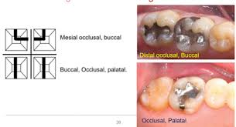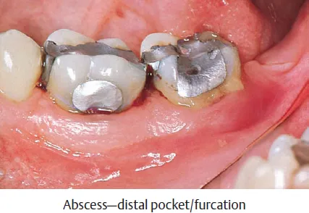

4 or more Surface Posterior Examples

D2394 - 4+ Surface Posterior Resin —--------> Downgraded Code 2161 - 4+ Surface Amalgam

D2394 - Mesial Occlusal Distal Lingual (MODL) D2394 - Mesial Occlusal Distal Buccal (MODB)

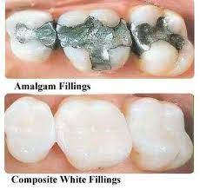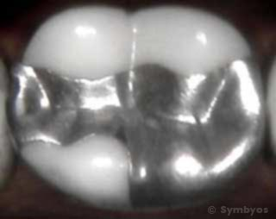

D2394 - Mesial Occlusal Distal Buccal Lingual (MODBL)

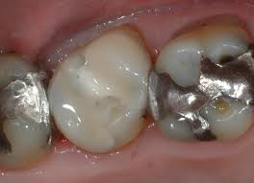

Endodontic Codes - D3000 - D3999

Endo codes can fall under Basic or Major services

D3110 - Pulp Cap - Direct
- A Procedure in which the exposed pulp (or nerve) is covered with a dressing that protects the pulp and promotes healing and repair
**Insurance will NOT pay for this on the same day as a filling - ALWAYS ESTIMATE NO COVERAGE**

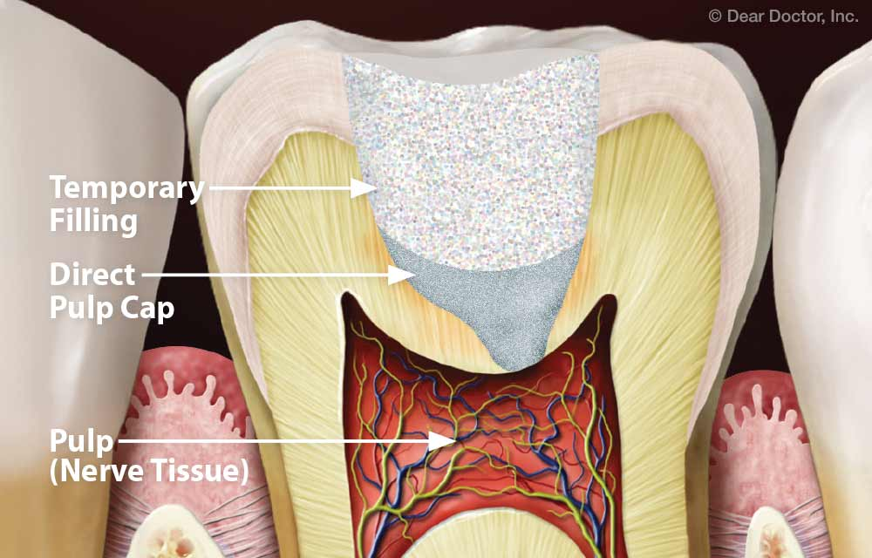

D3120 - Pulp Cap - Indirect

- A Procedure in which the NEARLY exposed pulp is covered with a protective dressing to promote healing and repair

**Insurance will NOT pay for this on the same day as a filling - ALWAYS ESTIMATE NO COVERAGE**

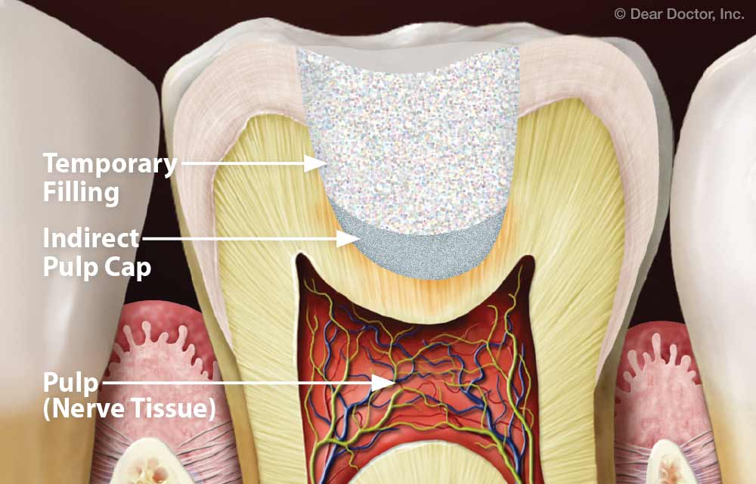

D3310 - Endodontic Therapy, Anterior tooth

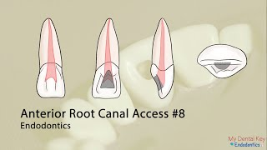
**A hole will be drilled into the tooth (usually on the lingual surface) to access the nerve.
THERE ALWAYS NEEDS TO BE A FILLING ON THE TREATMENT PLAN TO CLOSE THE HOLE. In this case, it will be D2330 - Lingual Surface**

For Treatment Plan: D3310 #8
D2330 - Lingual # 8

D3320 - Endodontic Therapy, Premolar tooth

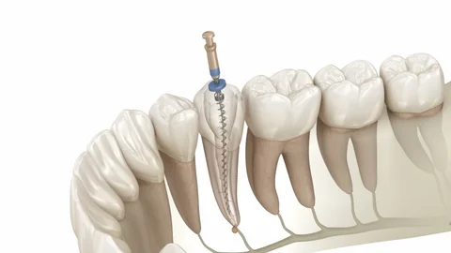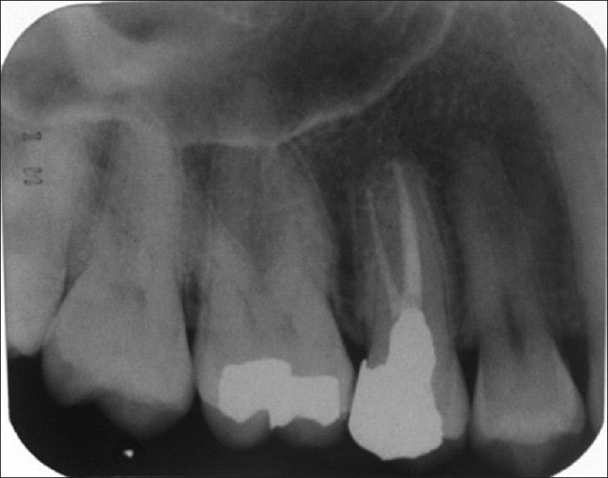

*Most often when a bicuspid has endodontic treatment - a crown and buildup will be placed to protect the tooth*

For treatment Plan: D3320 #12
D2950 or D2952 #12
D2740 #12

D3330 Endodontic Therapy, Molar tooth (Root Canal)

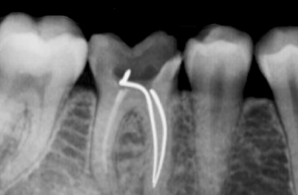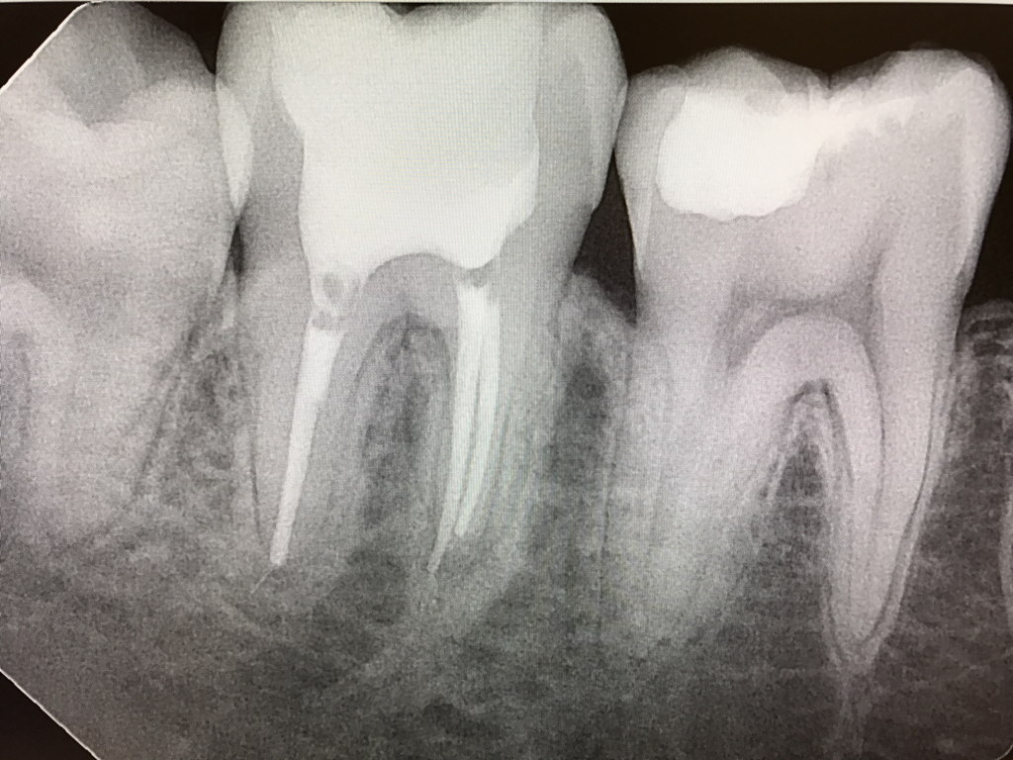

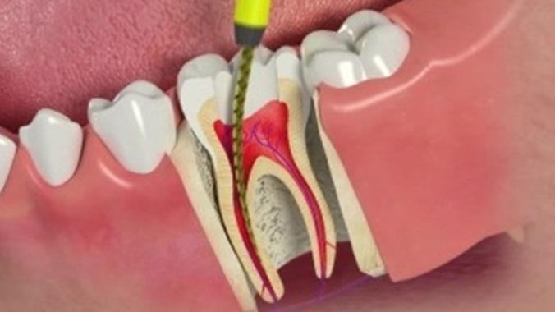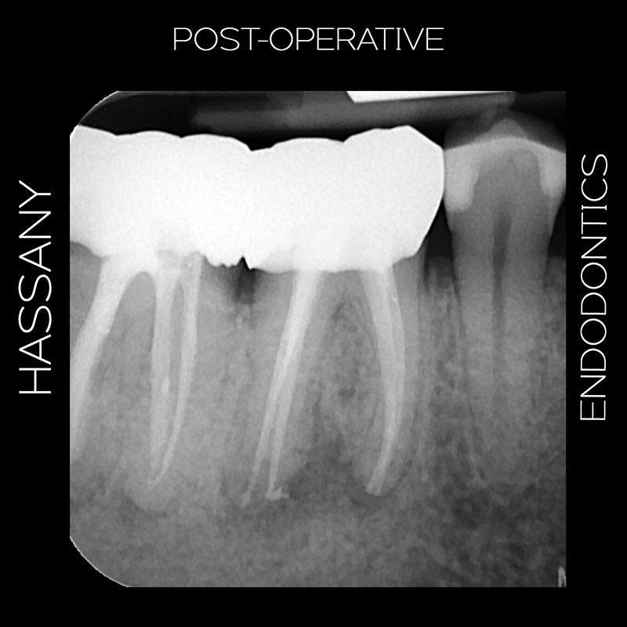
**When endo is completed on a molar tooth, a crown is placed on the tooth to protect the tooth from breaking**
For treatment Plan: D3330 #18
D2950 or D2952 #18
D2740 #18

**We will refer to an Endodontist if we are unable to complete endo successfully on that tooth**

After the root canal is completed by the endodontist, the patient will be referred back to our office for the final
restoration. The final restoration could be any of the following:
- Filling - On an anterior tooth or could be on a posterior tooth that has an existing crown
- Build up and Crown

Periodontic Codes - D4000 - D4999

**There are many codes for periodontics - I have entered the codes we use daily**

D4341 - Periodontal Scaling & Root Planing - 4 or more teeth per quadrant
- This procedure involves instrumentation of the crown and root surfaces of the teeth to remove plaque and calculus. Also, removal of cementum and dentin that is rough and/or permeated by calculus or contaminated with toxins and microorganisms
- Some soft tissue removal also occurs
- Patient is typically numbed for this procedure
- Billed per quadrant (Patient is likely to have all 4 quadrants - UR, LR, UL, LL)
- Insurance will typically have a frequency associated with this service
- Insurance may allow all 4 quadrants to be completed on the same day or may allow only 2 quadrants
- Perio charting and an FMX should be submitted for insurance to consider coverage
- This can fall under Basic services or Major services

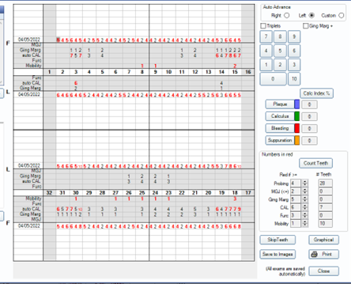

D4342 - Periodontal Scaling & Root Planing - 1 - 3 teeth per quadrant
- This procedure involves instrumentation of the crown and root surfaces of the teeth to remove plaque and calculus. Also, removal of cementum and dentin that is rough and/or permeated by calculus ro contaminated with toxins and microorganisms
- Some soft tissue removal also occurs
- Patient is typically numbed for this procedure
- Billed per quadrant (Patient may have all 4 quadrants or may be isolated to just one quadrant)
- Insurance will typically have a frequency associated with this service
- Insurance may allow all 4 quadrants to be completed on the same day or may allow only 2 quadrants
- Perio charting and an FMX should be submitted for insurance to consider coverage
- This can fall under Basic services or Major services

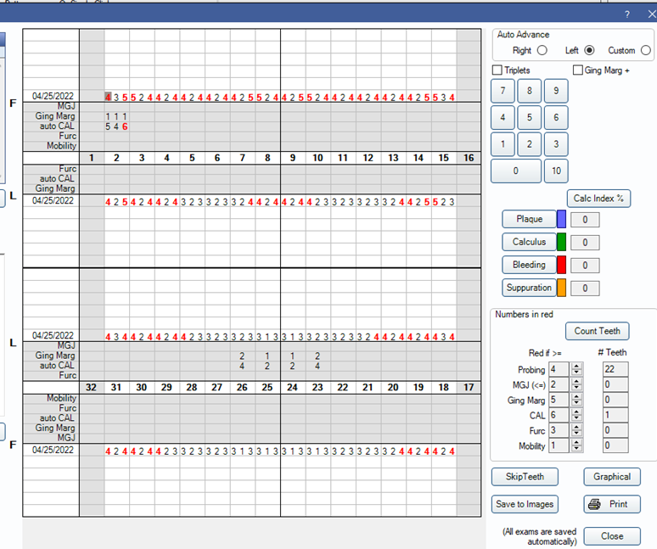
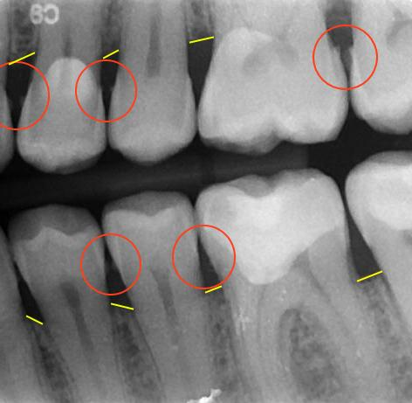

D4346 - Scaling in presence of generalized moderate or severe gingival inflammation
- The removal of plaque, calculus and stains from supra (above) and sub (below gums) gingival tooth surfaces when there is generalized moderate or severe gingival inflammation in the absence of periodontitis.
- This is indicated for patients who have swollen, inflamed gingiva (gum tissue), moderate to severe bleeding on probing
- This can fall under Preventive services, Basic services or Major depending on the insurance plan
- This code will typically be included in the frequencies for cleanings and/or perio maintenance cleanings

D4355 - Full mouth debridement to enable a comprehensive oral evaluation and diagnosis on a subsequent visit

- This involves the removal of plaque and calculus that interferes with the ability of the dentist to perform a comprehensive evaluation
- This cannot be completed with D0150, D0160 or D0180
- This may have a frequency of 1 per lifetime
- Also may have a limitation of no other preventive services within a certain time period

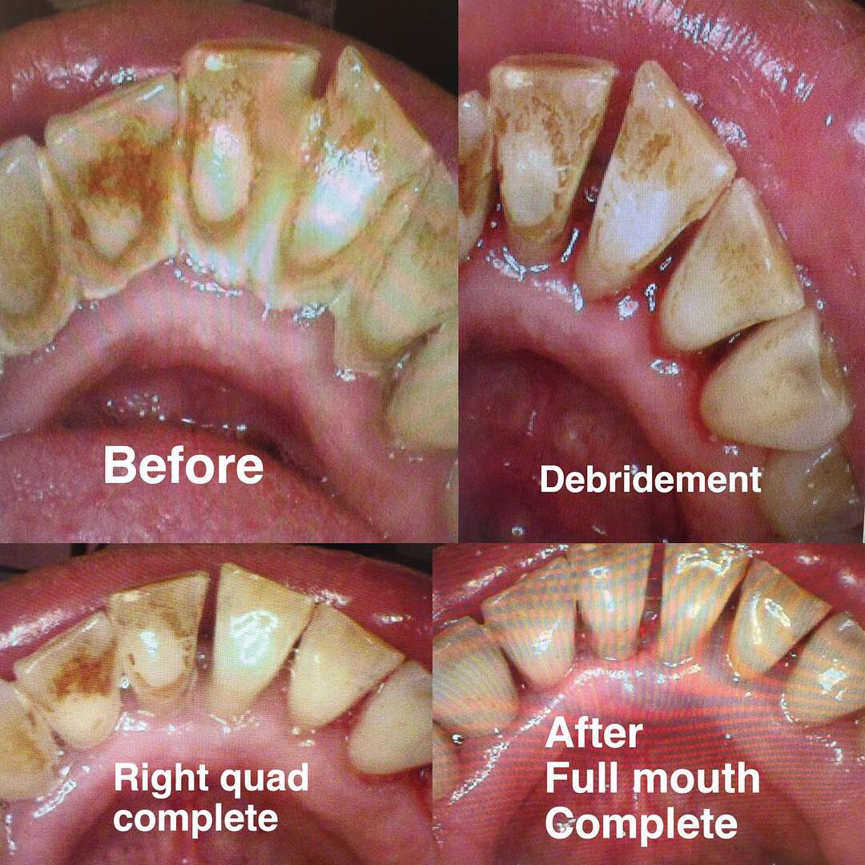

D4910 - Periodontal Maintenance
- This procedure begins following periodontal therapy (SRP) and continues at varying intervals, determined by the clinical evaluation of the dentist for the life of the dentition or any implant replacements
- This includes the removal of plaque and calculus from supra and subgingival regions, site specific scaling and root planing where indicated and polishing the teeth
- There will be a frequency associated with this code
- Some insurances will provide a frequency of 1 every 3 months or 4 per calendar year to allow more frequent cleanings
- This code may share the frequencies with the prophylaxis code (D1110)
- This can fall under Preventive, Basic or Major
- Hygienists and TC’s should be able to explain the insurance coverage for this code anytime scaling and root planing is completed or a treatment plan reviewed

D5000 - D5899 - Prosthodontics, removable
These codes are removable dentures or partials - These appliances are made to replace previously missing teeth to restore function or to replace teeth that are extracted.
- Missing Tooth Clause - will apply to these services

D5900 - D5999 - Maxillofacial Prosthetics

D6000 - D6199 - Implant Services
A dental implant is a procedure that replaces tooth roots with metal, screwlike posts and replaces damaged or missing teeth with artificial teeth that look and function much like real ones

This is most often the ideal treatment to replace any missing teeth
- The tooth may have been missing for a period of time
  - Missing Tooth Clause may apply
- The tooth may need to be extracted
  - Implant may be placed after the extraction site heals and will often include bone graft placement
  - Implant may be placed at the same time as the extraction and bone graft placed
- These codes will most often fall under Major categories and typical coinsurance is 50%, but can vary with each insurance plan
- Some insurance plans do not cover implant procedures
  - Be sure to clarify: If no implant coverage, they may consider just the implant crown (D6058)
- There are 3 components to the implant placement
  - D6010 - Implant Placement
  - D6057 - Custom Fabricated Abutment
  - D6058 - Abutment supported porcelain/ceramic crown
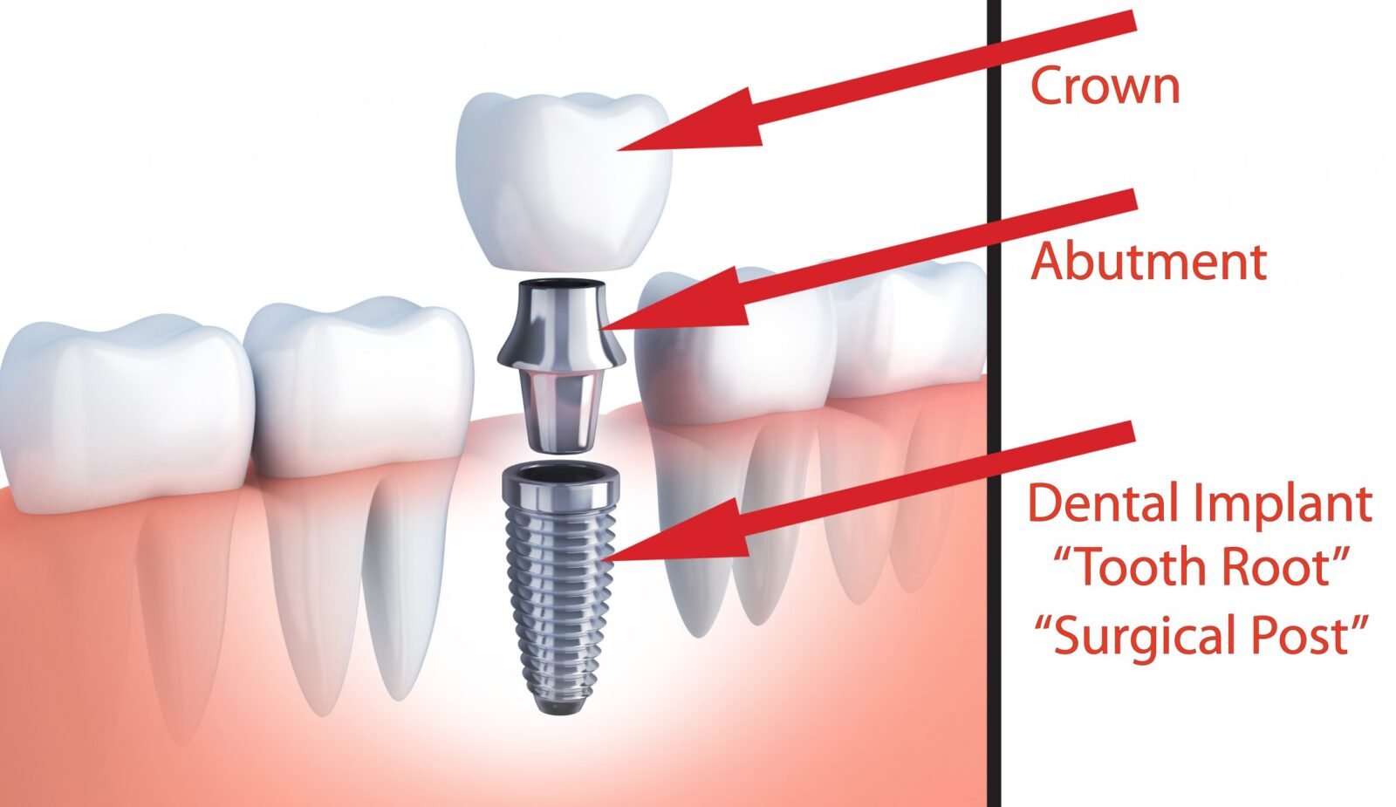
D6010 - Surgical Placement of Implant Body
After implant placement, the healing time will vary person to person. We are waiting for the bone to integrate with the implant as the surgical site heals and can take anywhere from 2 - 6 months

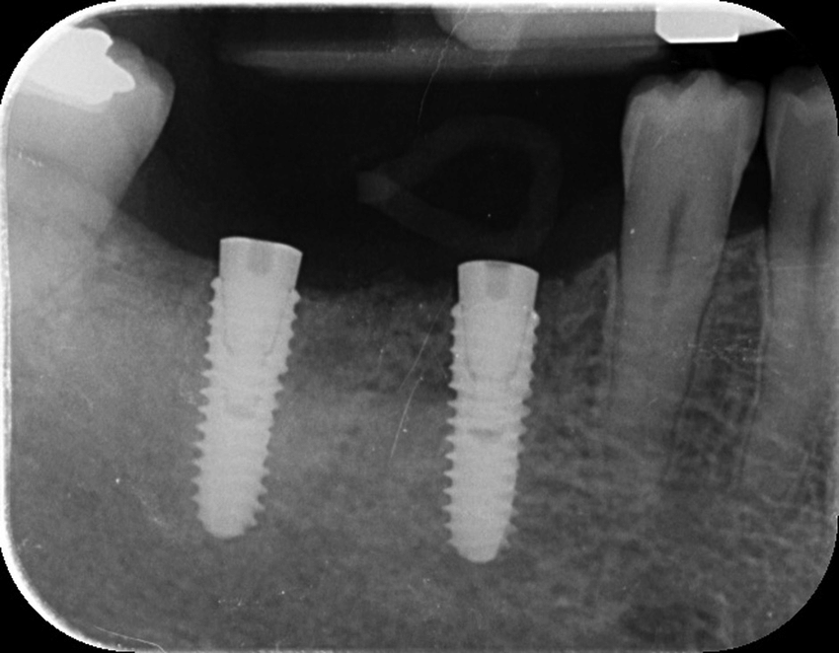
After healing time, the patient is ready to restore with the implant crown. This will consist of the abutment and the implant crown
D6057 - Custom fabricated abutment
D6058 - Abutment supported porcelain/ceramic crown
- Downgrade codes for the crown could be D6059, D6060

D6200 - D6999 - Prosthodontics, fixed
Fixed bridges will fall under this category. This also is used to replace teeth, but is cemented in place.
Most often will be a 3 unit bridge or a 4 unit bridge
- 3-unit bridge will be replacing 1 tooth. Consists of 2 crowns and 1 pontic
  - D6740 - Retainer Crown - Porcelain/Ceramic (2 of these)
  - D6245 - Pontic - Porcelain/Ceramic (1 pontic)
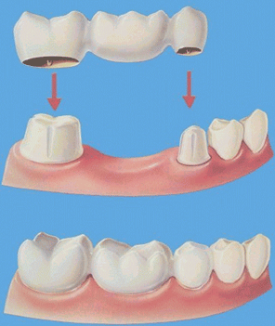

- 4-unit bridge will be replacing 1 tooth. Consists of 2 crowns and 2 pontics
  - D6740 - Retainer Crown - Porcelain/Ceramic (2 of these codes)
  - D6245 - Pontic - Porcelain/Ceramic (2 of these codes)
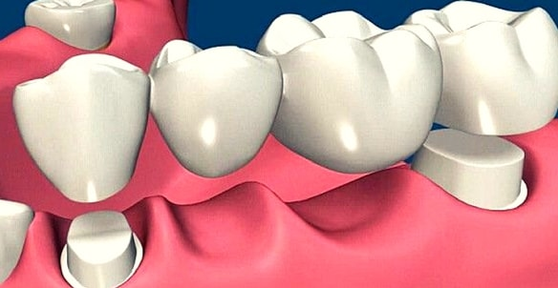
- Bridge also can be an implant supported bridge
  - D6075 - Implant Supported retainer for ceramic FPD
  - D6245 - Pontic - Porcelain/Ceramic

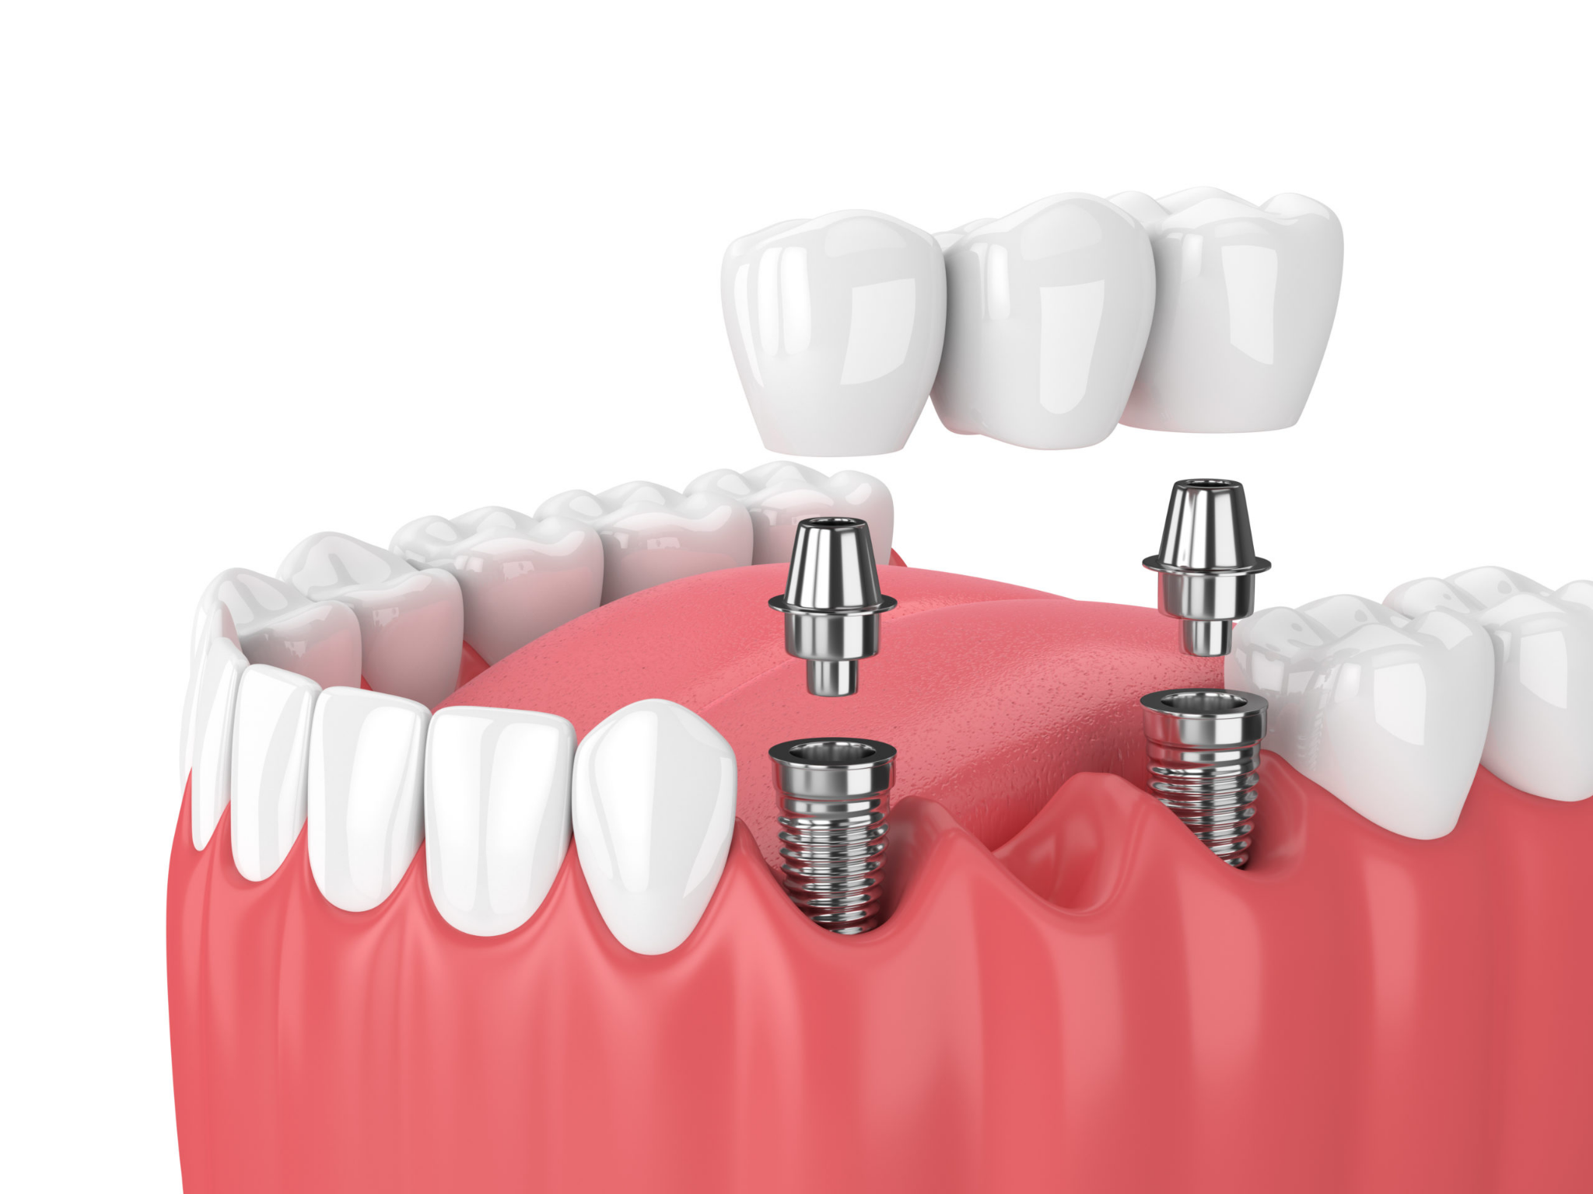

D7000 - D7999 - Oral & Maxillofacial Surgery
These codes include extractions, bone grafts, simple procedures to even more complex procedures
- These codes can be covered under Basic Services
- May be covered under Major Services
- May be a combination of Basic and Major Services and is code specific

D7111 - Extraction, coronal remnants - primary tooth (A - T)
- Removal of soft-tissue retained coronal remnants
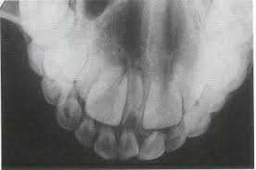

D7140 - Extraction, erupted tooth or exposed root (elevation and/or forceps removal)
- Includes removal of tooth structure, minor smoothing of socket bone, and closure, as necessary
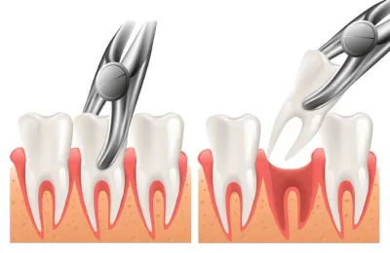
D7210 - Extraction, erupted tooth requiring removal of bone and/or sectioning of tooth, and including elevation of mucoperiosteal flap if indicated or exposed root (elevation and/or forceps removal)
- Includes related cutting of gingiva and bone, removal of tooth structure, minor smoothing of socket bone and closure
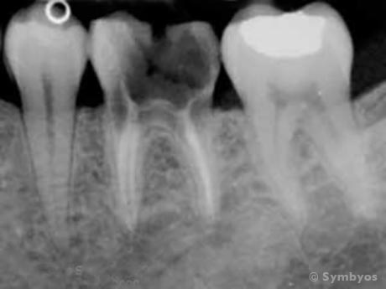

D7220 - Removal of impacted tooth - soft tissue
- Occlusal surface of tooth covered by soft tissue: requires mucoperiosteal flap elevation

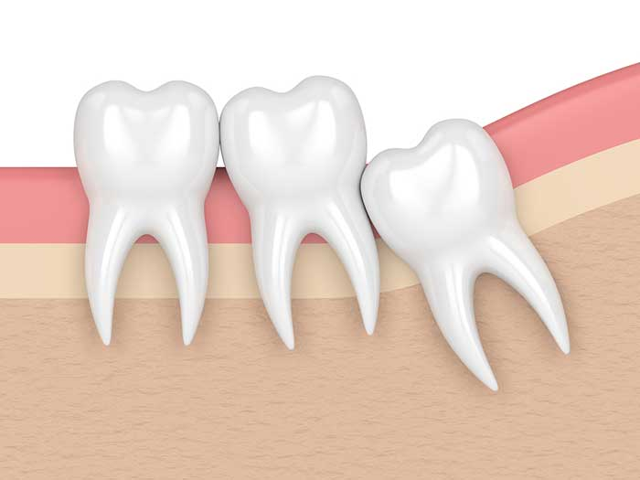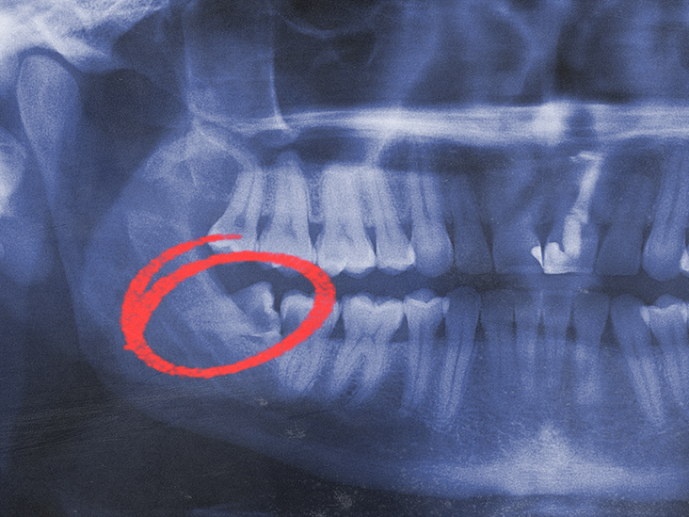

D7230 - Removal of impacted tooth - partially bony
- Part of crown covered by bone
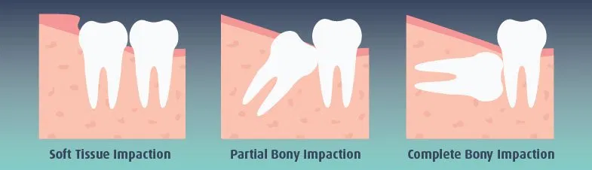

D7240 - Removal of impacted tooth - completely bony
- Most or all of crown covered by bone

D7953 - Bone replacement graft for ridge preservation - per site
- Graft is placed in an extraction or implant removal site at the time of the extraction to preserve ridge integrity in preparation for implant
  - We will estimate at no insurance coverage. Most companies will not cover bone grafts
  - The best time to place a bone graft is when the extraction is done and most companies will not cover on the same day as extraction
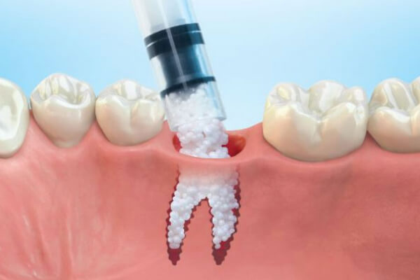

D8000 - D8999 - Orthodontics
In our offices, we do Invisalign on adult patients and use the following codes:
D8090 - Comprehensive orthodontic treatment of the adult dentition
- 1 set of retainers is included
- 2 tubes of bleach is included
- Some insurances have adult ortho coverage and usually is covered at 50%
  - The patient must stay active on the current plan to receive the full ortho benefit
  - Insurance companies can pay monthly or quarterly depending on the plan
Based on the amount of treatment time, the following discounts can be applied:
- Level 1 Express: $500.00 discount
- Level 2 Express: $1000.00 discount
- Level 3 Express: $1500.00 discount
- Level 4 Express: $2000.00 discount
- Level 5 Express: $2500.00 discount
The sequence and codes for Invisalign scheduling is as follows:
D8090.2 Invisalign Consult (30 minutes)
D8090.3 Invisalign Records (20 - 30 minutes)
D8090 Comprehensive ortho adult dentition (60 minutes)
d8670 Periodic ortho visit (20 - 30 minutes)
D8680 Retainer Delivery

Other ortho codes - ALL BELOW CODES ARE NOT TYPICALLY COVERED BY INSURANCE, SO WE WILL ESTIMATE $0.00 COVERAGE
D8695 - Removal of fixed orthodontic appliances for reasons other than completion of treatment
D8698 - Re-cement or re-bond fixed retainer - maxillary
D8699 - Re-cement or re-bond fixed retainer - mandibular
D8701 - Repair of fixed retainer, includes reattachment - maxillary
D8702 - Repair of fixed retainer, includes reattachment - mandibular
D8703 - Replacement of lost or broken retainer - maxillary
D8704 - Replacement of lost or broken retainer - mandibular

