Universal On-Boarding

High level

1. Core Values
   1. Fantastic Guest Experience
   2. Always be Improving
   3. Hungry and Humbly Confident
   4. Have Each Other’s Backs
2. Cadence of Accountability-
   1. Morning Huddles
      1. Start promptly at 7:45am each morning before we see patients
      2. Each column (hygiene 1/2/3, doctor 1, surgical 1/2) will go through each of the following about pts in their column:
         1. Pts with balances
         2. Other treatment in their chart not yet scheduled that could potentially be completed same day, schedule allowing
         3. Scheduling conflicts/issues
         4. Note if a pt is being seen by hygiene or doctor before/after coming to your chair
   2. [Weekly Growth Meetings](https://docs.google.com/spreadsheets/d/1Ipsm_pdgAteGxDeYSQt6ujWzByfbyptlr6mkFLU9kKU/edit?usp=sharing)
      1. Every Tuesday over lunch (30mins weekly/1.5hrs monthly)
      2. Each person chooses a lead measure to focus on pertaining to their position (See hyperlink for examples of lead measures for each position
      3. During the weekly meeting each person is held accountable for meeting their lead measure they chose the previous week (was the goal met or not), new or different goals are created for each staff member
   3. Quarterly Off-Site Meetings
      1. 4(ish) hour meeting held quarterly to review newly implemented policies or procedures
      2. Team bonding time
      3. Discuss/resolve issues noticed since the last meeting
3. Payroll- How it works
   1. Gusto (third party payroll service) - how you get paid
   2. Bi-weekly pay system
4. [Employee Manual](https://docs.google.com/document/d/1BNmr6x0RwSACcTgWeNHwgUt9A-dB4V2UgdjTxsNAuag/edit)
5. Where to park

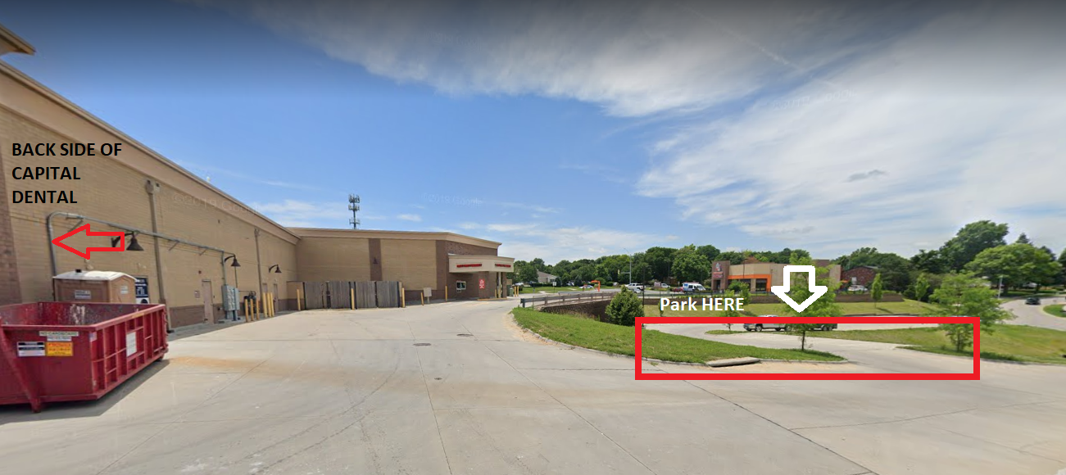

1. How to clock in
   1. Log in to Open Dental
   2. Click the “Manage” tab on the left hand side
   3. Find your name under the list of employees and click on it
   4. Under displayed time choose either click Clock In, or choose “Home/Lunch” and click Clock Out For

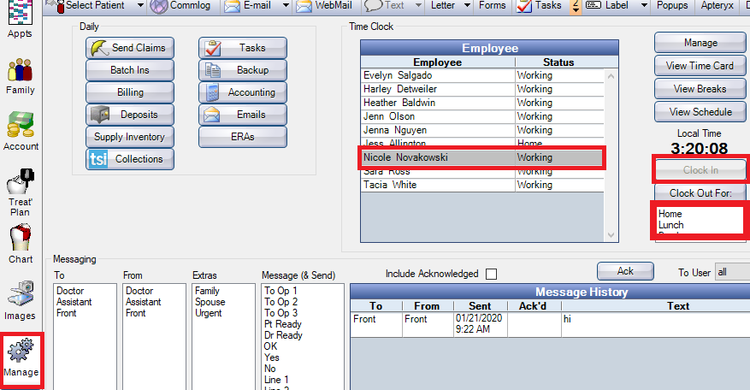

1. Break room etiquette and where to store items
   1. Any food in the cupboards is up for grabs- help yourself
   2. We are all coffee fiends so whoever is available make a fresh pot before huddle/first pt :)
   3. Wash your OWN dishes
   4. There are lockers in front of the fridge with locks if you want to keep your purse/coat/personal dry foods in them
   5. We are all responsible for keeping the breakroom tidy and somewhere appealing enough to eat in
2. How to use OpenDental (DOCUMENT)
3. How Chairs work-
   1. Each chair is pre-programmed to tip the pt back and set them up per the Dr’s preference
      1. Click the A on either side of the back of the chair to tip the pt back
      2. Click the E on either side of the back of the chair to sit the patient back up
      3. Adjust the tilt or base of the chair with the respective arrow buttons
   2. Why Surgical Chairs are different
      1. The base of the surgical chairs raise all the way up so the doc/assistant can stand for surgery
4. How Clear Tubs are meant to work
   1. Referred to as “el cheapo’s”
   2. Meant to help reduce hallway traffic by keeping stock in each room
   3. One box should have all disposables (2x2 gauze, cotton rolls, cotton tipped applicators, hve/saliva ejector tips and any anesthetics/needles)
   4. The other box (doctor side) will have restorative materials (composite, etch, prime/bond, flowable, composite gun etc) See pictures in Op Manual for reference
5. [How Nitrous Works](https://docs.google.com/document/d/1HdlKED_4YOmz6ln1KMckJJriGRgkrlocVT8-vDZ7oIY/edit)
6. [Sedation protocol](https://docs.google.com/document/d/1zC1MnTquNTVHRbo8oOJLSBIIRX8lmjyStdd3lnrWX0c/edit?ts=5eb56079)
7. How Suction and Pumps Work
   1. Pumps are turned off each night by the last person out of the office, and turned back on again by the first person to arrive the next morning
      1. On/off buttons located right next to the back door
   2. Traps are changed weekly in each operatory- you are responsible for your own room
8. How Sterilization works/flows
   1. The lab is the start of the sterilization area, the lab is included in the “dirty side” of sterilization
      1. Starts with the grinder→ sink → vibrating machine/lab handpiece/suck down stint machine
      2. “Dirty side” continues to ultrasonic unit → sink → packaging area
      3. Two utraclaves separate the dirty side of sterilization from the clean side (NO DIRTY GLOVES SHOULD TOUCH THESE MACHINES) {open/remove trays with clean ungloved hand, load trays with gloved dirty hand}
      4. Ultraclaves are unloaded to the right of the machines to the clean side of sterilization, items will then be placed on trays or put away in clean cupboard to the right of the counter
9. [How Pano/CBCT Work](https://docs.google.com/document/d/1ZPMPAlKZX9lOP_an2k_phqngm70wlXSb6dKz3ejwsas/edit)
10. [Organizational Structure](https://drive.google.com/open?id=1Xa6kbrtI5J-foU4uYsQZT4CZXGK5fHxf)
11. Who to call when sick
    1. Tacia (402) 363-1960
    2. Dr. Killeen/Chapek
    3. Group Chat if looking for coverage
12. Who is manager/supervisor
    1. Dr. Killeen / Dr. Chapek at the moment
13. How Sedation patients are scheduled
    1. 1st is consult for 30-50 minutes in 3rd column
    2. Sedation appointments are 1.5hrs-2hrs and several things are required prior to scheduling
       1. NEED:
          1. Referral from general dentist
          2. Track pt info on oral surgery spreadsheet
          3. X-rays/Pano for 3rds
          4. New Patient paperwork filled out
          5. Sedation Videos watched
14. Flow of a Patient through the office
    1. Pt enters the practice and checks in with front desk
    2. Assistant/Hygienist brings pt back (gives office tour if new patient) and seats them in the operatory
    3. If possible the assistant will check pt out for services completed that day
    4. Hygiene will be trained to check out for fluoride to avoid congestion at check out up front
    5. If not able to check pt out (questions/large balance) bring pt up to the front to one of the two check out stations
    6. If noone is available at the designated checkout take pt to front desk or seat pt in waiting room and let them know that someone will be with them asap
       1. Leave completed routing slip with Tacia face down at her desk so she knows to help your pt next
15. Membership Plan
    1. One time $49 fee, no yearly
    2. $21, Kids, $24 Adults, $37 Perio per month (have to do monthly payments cannot take the full fee at once)
    3. X-rays and exams
    4. Cleanings covered (frequency depending on the plan)
    5. 20% off all other services